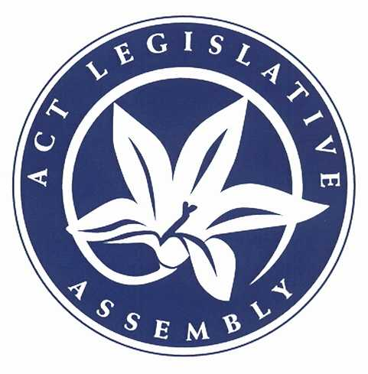

**Overview**

The ACT Legislative Assembly’s parliamentary education unit (within the Governance and Communications Office) aims to promote an understanding and appreciation of the role and significance of the Legislative Assembly to the citizens of the ACT and its visitors.

The Assembly’s education office provides a range of services including:

• learning activities for primary and secondary students

• tours for community groups and individuals

• specific programs for senior secondary students such as parliamentary debates, youth parliament and the ACT Schools’ Constitutional Convention

• specific programs for the ACT public service

• specific programs for community groups

• work experience and internships for secondary and tertiary students

• the provision of information, educational and promotional publications on the assembly in print and electronic formats

• the organisation of an open day once per sitting term

• managing the Assembly’s official gift and art collections

**Staffing**

The Education Officer is responsible to the Speaker through the Director, Governance and Communications. The office is staffed by one full-time Education Officer and a part-time Assistant Education Officer. The success of the program also relies on support from members and Office of the Legislative Assembly (OLA) personnel as follows:

• the Speaker, Deputy Speaker and Assistant Speakers to preside over parliamentary debates

• members speaking to visiting groups

• the Public Affairs Officer

• OLA staff delivering presentations in their area of expertise

• attendants assisting with setting up for visits and major functions

**Education**

The ACT Legislative Assembly has created a number of factsheets and frequently asked questions (FAQs) regarding the ACT Legislative Assembly — its history and creation, how the Assembly works, and some information on the electoral process for the general public. This material is primarily aimed at informing the public about the roles, responsibilities and history of the ACT Legislative Assembly.

All fact sheets are available from the ACT Legislative Assembly website:

[parliament.act.gov.au/](http://www.parliament.act.gov.au/)

**Primary, Secondary & Tertiary Education Programs**

Include the following:

• Australian National University/University of Canberra/ACT schools Internship Program – annual event

• ACT Schools Constitutional Convention – annual event

• Indigenous Education Program

• Inter-School Parliamentary Debates – five per year (2 x Yr 8/9, 2 x Yr 10, 1 x Yr 11/12

• Teachers’ Personal Development

• Work Experience Students

• YMCA Youth Parliament

**Adult Education programs**

• Community/Organisation seminars eg. Probus Club, Goodwin Men’s Shed, and many others

• Assembly Orientation and Tours

• English as a Second Language (ESL) Programs in conjunction with the Canberra Institute of Technology

• Committee Role Play

• Older Persons Assembly

• U3A

*Public Service Seminars*

Public Service Seminars are half-day events involving members of the ACT Public Service or staff from the ACT Legislative Assembly and are run four times a year on the following subjects:

• An Introduction to the ACT Legislative Assembly

• The Budget Process

• The Role and Operation of Assembly Committees

• The Legislative Process

*Speaker's Citizenship Evenings*

Citizenship ceremonies are organised by the Office of Multicultural Affairs at the Theo Notaras Multicultural Centre. Four times a year the Speaker invites the new citizens to an informal evening to meet some members, learn about the Assembly and take a tour.

**Art**

The Legislative Assembly Art Advisory Committee [LAAAC] was established to oversee the purchase and management of the Assembly’s official art collection. The committee includes representation from the art community, a member from the government, opposition and crossbench, and is presided over by the Speaker. The Director, Governance and Communications attends the meeting as an observer. The Education Officer is responsible for updating the art catalogue, the record of all items in the art collection, and their current location, a brief description and link to a photo.

**Gifts**

The Education Office manages the gifts received by the Assembly, as well as providing a store of items to be presented on behalf of the Assembly.

**Future Priorities**

Continue to revise and refine programs. Work with students, the ACT community, and Legislative Assembly Members and staff, to respond to our client’s needs and meet the strategic objectives of the Education Office.