**UNIT OVERVIEW**

Parliamentary Education Services (PES) is responsible for promoting community awareness of the constitutional role and significance of the Northern Territory Parliament. PES is located within the Department of the Legislative Assembly and is staffed with three permanent positions of Director, Community Engagement Coordinator and Education Promotions Officer, along with three casual tour guides who conduct our free public tours.

This year an external review into PES was conducted and the recommendations are still being considered. In conjunction with the review, PES was integrated into the Chamber Support Unit, which includes the Table Office and Hansard. There may be further changes as a result of the review’s recommendations and these will be implemented in early 2014.

**SCHOOL PROGRAMS**

All of our school programs are conducted by our three permanent PES staff members.

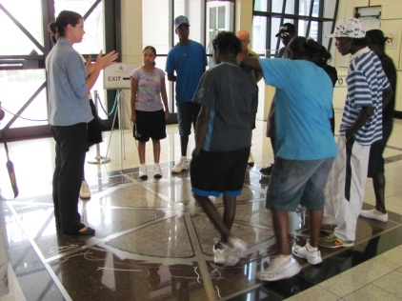**SCHOOL TOURS** of Parliament House remain our most popular program. On sitting days we offer a two hour program which comprises a one hour tour including a viewing of the sittings, and a presentation and mock election from the NT Electoral Commission (NTEC). NTEC provides funding for buses to those schools taking part in this program. During sittings students often have access to Members as part of their visit. PES also conducts school tours on non-sitting days on request. During 2012/13 PES conducted 118 tours to 2166 students and teachers.

**Milingimbi School senior students**

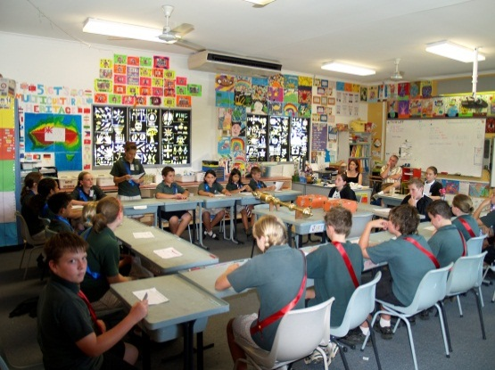**ROLE PLAYS** are conducted at schools on request, often as a follow up to a school tour. After a PowerPoint presentation, students brainstorm bill ideas, vote on a bill and write a speech supporting or opposing the bill. Every student is given a role. The length of the role play is negotiated with teachers, but is usually about two hours. During 2012/13 PES conducted 28 role plays to 632 students, but numbers for this financial year should improve with 21 role plays already completed.

**St Paul’s Catholic Primary School**

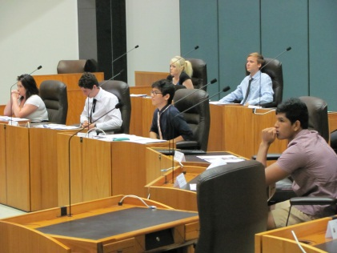**STEP UP, BE HEARD** is our customised Youth Parliament program for senior students. At one Darwin high school it has become an assessable part of its Year 11 Legal Studies unit. *Step Up* is an election campaign and vote conducted by NTEC. *Be Heard* is a bill debate in the Chamber with the Speaker presiding. It is conducted over about four weeks of class time at both the school and Parliament House.

**Darwin High School students**

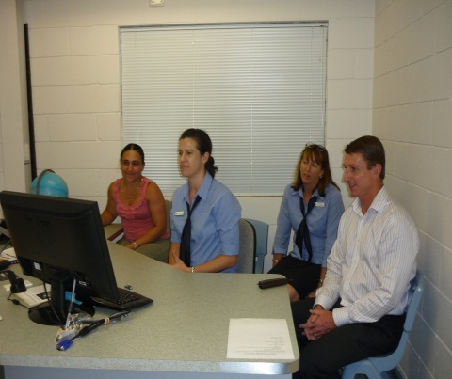The **REGIONAL OUTREACH PROGRAM** mirrors the role play program held in urban centres, but sometimes uses activities designed for remote indigenous students depending on the class. This program is run on request from teachers, and then other schools nearby are offered a visit. Every year we visit schools in bigger regions like Alice Springs and Katherine on request, and other regions more intermittently. So far this year we have run 12 sessions for 280 students in regional areas.

**Katherine School of the Air**

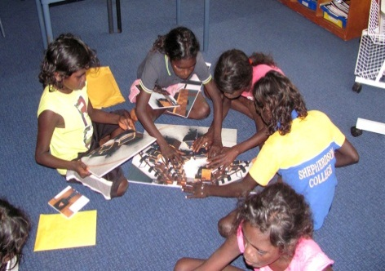The **REMOTE SCHOOLS OUTREACH PROGRAM** was specifically designed for remote indigenous students and involves a series of hands on activities and visual resources leading up to a modified role play. The program sets out to overcome challenges of lower literacy levels among ESL students taking into account the learning styles of remote indigenous students. This program is also run on request, with nearby schools also offered a visit. This year we have conducted 18 sessions to 290 students.

**Shepherdson College – Galuwin’ku**

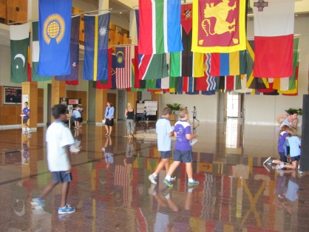**SPECIAL EVENTS FOR SCHOOLS** are conducted on an annual basis. These include: *Bombing of Darwin tours* which run over a two week period surrounding the 19th February anniversary of the 1942 bombing. These tours are conducted in conjunction with the NT Library located in Parliament House. In March we hold a week long program for *Commonwealth Day* where students learn about the different countries in the Commonwealth. Parliament House puts on an impressive display of all the flags of Commonwealth countries every year. Law Week and National Careers Development Week fall in the same week in May when PES holds a *From Cabinet to Court – Careers in Law* forum with two speakers from parliamentary positions and two speakers in judicial positions. PES also facilitates the parliamentary aspects of the YMCA Youth Parliament and Leadership Camp in July.

**Commonwealth Day – Larrakeyah Primary School**

**ADULT EDUCATION**

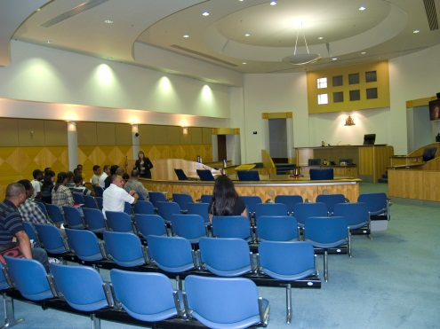**DEMOCRACY AT WORK** is aimed at “new arrivals” (i.e. new immigrants and refugees) to facilitate their understanding of the democratic systems in Australia. It focuses on the three pillars of democracy – voting, parliament and the justice system. NTEC run their school program including a mock election, PES conduct a tour and information session about our parliamentary system, and the Supreme Court (located next to Parliament House) conduct a tour and question and answer session with a Judge. Leanne will be speaking more on this program as part of the conference.

**East Timorese ESL students at the Supreme Court**

**COMMUNITY/ORGANISATION TOURS** are run on request for community groups and organisations. These tours of Parliament House have increased content about the history of parliament in the Northern Territory to suit its audiences. These are becoming more popular, especially with visiting groups from interstate.

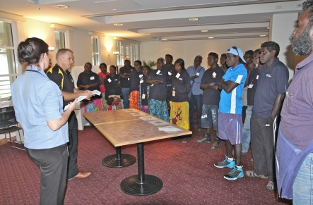**KNOW YOUR PARLIAMENT** is a program directed at community groups and organisations. It involves information sessions with the content of these sessions being negotiated with the group or organisation, and they are conducted at a venue of their choosing, including Parliament House. Know Your Parliament sessions are now regularly included in *Machinery of Government* and *Public Servant Management* courses for government employees.

**Building Up Good Supervisor Skills course participants**

**PARLIAMENT PROMOTIONS**

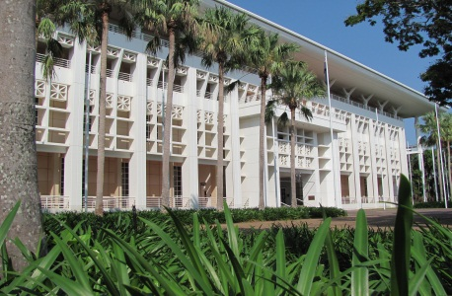**PUBLIC TOURS** are conducted every Saturday at 9am and 11am, with an extra tour at 10:30am on Wednesdays during the Dry Season (May – September). Due to budget cuts we no longer run public tours during December and January, when tourist numbers are at their lowest. We have three casual public tour guides who rotate the shifts, and during the Dry PES staff are sometimes required to help out on busy Wednesday tours.

**NT Parliament House**

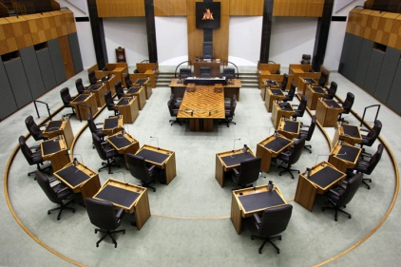There are number of **OTHER TOURS** run by PES staff on demand. These include tours and inductions for departmental or ministerial staff and electorate officers. We also conduct VIP tours for visiting delegations of parliamentarians or government officials, as well as trade delegations or guests of the Chief Minister or other Ministers.

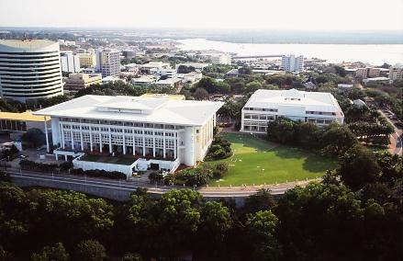**OPEN DAY** is now an annual event, and is held in conjunction with Government House and the Supreme Court, all located within metres of each other. As well as a number of displays, this year there were regular public tours run by PES, Chamber talks by the Speaker and Clerk and architectural talks by one of the construction managers involved in building Parliament House. Next year the Speaker is considering a stand-alone Open Day later in the year to coincide with the 20th anniversary of the opening of Parliament House and the 40th anniversary of the first sitting of the new Legislative Assembly after the granting of Self-Government.

**Parliament House and the Supreme Court**

**FUTURE PRIORITIES**

* Develop and implement further online interactive resource materials suitable for schools
* Develop and implement further interactive programs for two touchscreen information kiosks that PES manage
* Promote our adult education programs further to increase attendance
* Align our programs and school resources to the new Australian Curriculum