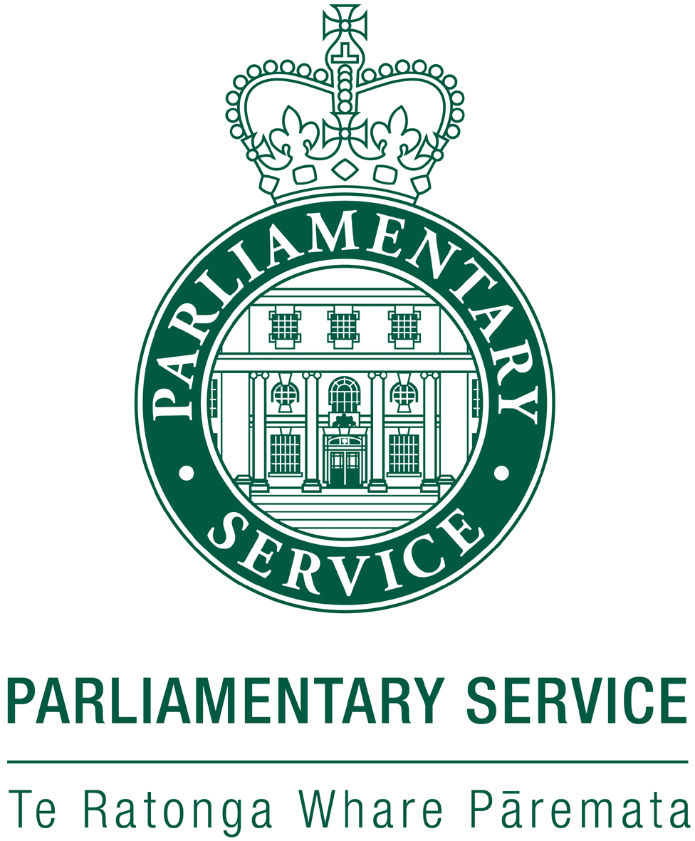

Nau mai, haere mai

Civics education is alive and well in New Zealand.

That is not to say that there is still not plenty more to be done. We are always looking at new opportunities to strengthen and build on our current achievements and find better ways to interest and engage with young people.

This year we have brought to a close some initiatives which have been in the pipeline for the past two years and it is great to see them reach completion but we are also careful not to rest on our laurels and have lots of ideas to take us forward over the next couple of years.

I will now outline for you some of the activity which has kept us busy over the past year:

**Educational Visits**

A large part of Education Services function continues to be our education visits. At present we still offer two types of visit.

There is a 90 minute standard visit (up to 42 pax per visit including adults) which can be tailored to the needs of the group and an active debating role play (Years 5-8) which is two hours long.

The standard 90 minute visit also allows for a visit from an electorate MP if available. Afternoon visits on a House sitting day also include 20 minutes in the public gallery watching question time. Numbers have been steady over the past year but we have noticed an increase in MP meeting with groups. A new trend is the number of groups visiting in the morning will return in the afternoon to sit in the gallery as well.

The role play option has continued to be taken up but by smaller number of groups and so we decided it needed a bit of a refresh. We have developed some new bills to debate and have updated and enhanced the original format to allow students more opportunities to really think about the issue they are debating and develop arguments for and against. A power point for each bill presents some ideas for the students to discuss to help them write their speeches. We also allow schools to video the experience and have two press gallery roles to record the debate and take notes on the outcome. In the 2014 school year we will be promoting the role play to schools and providing a clip on the website for teachers to view so they can better understand what the experience involves.

**New Tour Options**

In 2014 we will also be developing a menu of 6 tour options which teachers can choose from. Each option will be fully described in our promotional material so teachers know exactly how long and what content each visit will cover. We hope this will make choosing and booking a visit easier and that schools can make repeat visits with quite different content. Some visit will be seasonal or topical. For example because election year is coming up in 2014 one tour option will be directly related to elections in the build-up to the elections. Other options will include a visit with a focus on women in parliament and another which looks at the treaty of Waitangi and its influence on the work of Parliament.

|  |  |  |  |  |  |  |
| --- | --- | --- | --- | --- | --- | --- |
| **Education Services - Summary of 2012/2013** | | | | | |  |
|  | **No. of Groups** | **Total number of Students** | **MP Visits** | **Role-plays** | **Gallery** |  |
| **July** | 28 | 629 | 6 | 0 | 13 |  |
| **August** | 54 | 1466 | 21 | 0 | 25 |  |
| **September** | 67 | 1887 | 34 | 0 | 21 |  |
| **October** | 27 | 688 | 6 | 1 | 6 |  |
| **November** | 100 | 2725 | 33 | 5 | 26 |  |
| **December** | 32 | 878 | 9 | 1 | 13 |  |
| **January** | 3 | 85 | 1 | 0 | 1 |  |
| **February** | 28 | 714 | 2 | 0 | 9 |  |
| **March** | 40 | 1145 | 11 | 2 | 11 |  |
| **April** | 31 | 877 | 8 | 3 | 10 |  |
| **May** | 48 | 1243 | 9 | 1 | 14 |  |
| **June** | 51 | 1210 | 11 | 1 | 15 |  |
| **Total** | **509** | **13547** | **151** | **14** | **164** |  |
|  |  |  |  |  |  |  |

**Staffing**

Staffing has remained stable this year. My role is still a fulltime one and we have the equivalent of another full time person but this is shared between two staff members with one working four days a week and the other one day. For the duration of the project work we have has another staff member on a fixed term contract for 3 days a week to allow for the extra time needed to cover the projects being developed. This staff member has now been employed on a casual contract and is coming in on average two days a week.

Having a bit more flexibility with covering visits has been great and allowed for more staffing to cover busy periods and given us the ability to book more visits on certain days than has been possible.

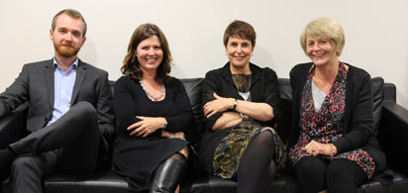

Here is the team- Ben, Jo, Miranda and Lynette

**Educational Resources**

For the past two years Education Services have been working on several projects to provide fit for purpose resources which can support and enhance visits to Parliament or be used as stand-alone material for classroom teachers undertaking studies around the work of Parliament. All these projects will be complete as of the end of November and available free to schools.

These resources include an interactive timeline with 100 dates from the history of our NZ Parliament, a virtual tour of the buildings with icons that can be clicked on to provide information and hard copy resources including teachers guides with links to the curriculum. The hard copy resources include for the first time bi-lingual resources for use in Māori medium schools. NZ has a network of schools which teach students exclusively in Māori so we felt this was an important step to ensure all students have access to material about our Parliament.

The timeline will be available on the Parliament website and will be able to be accessed not only by teachers but the general public as well. This is also true of the virtual tour

The hard copy resources include:

**Explore Parliament**

* Role playing a parliamentary debate: a guide for teachers
* Set of 10 topic cards (Years 5-8)
* Teachers guide (Years 5-8)
* Set of 10 topic cards (Years 9-10)
* Teachers guide (Years 9-10)

**To Tātou Whare – He Aratohu mā ngā Kaiako**

* Set of 6 topic cards (in Te Reo Māori)
* Teachers guide (bilingual)

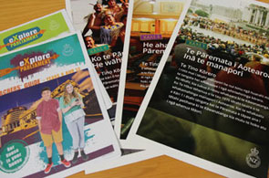

We have generated a data base from teachers who have visited Parliament and will be sending out information about these resources which will be available on request. We have chosen to target individual teachers rather than a blanket mail out to schools since our previous experience with resources has shown this is the best way to ensure the resources are used and not stuck in a dusty resource room. It also means that as teachers move around they take the resources with them

Editorial material will also be appearing in several publications including the Education Gazette which is sent to all schools in New Zealand. We expect the uptake of these resources to be very strong and have printed numbers accordingly. Feedback forms will be included with the resources so we can make any necessary changes or improvements, based on feedback, for the next print run if necessary. We will have the print files for the resources so we can update or tweak them as needed

**Education Centre Refurbishment**

To complement the new resources we have developed the classroom has been refurbished and is now known as the Education Centre. The aim was to create a space which provided students with a sense of the special environment they are visiting. We have received lots of positive feedback on the ‘new look’ and it certainly adds atmosphere to our role play sessions. Part of the new furniture includes units with drawers which we are planning to fill with interesting objects from the parliamentary collection. These can be used with groups to stimulate discussion and provide a more tactile experience for students when required.

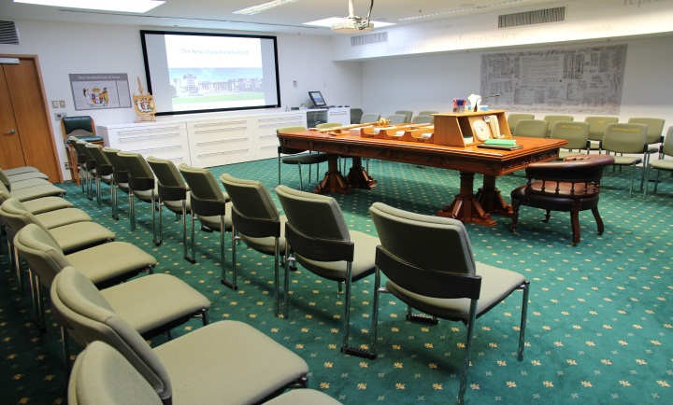

The new Education Centre, NZ Parliament

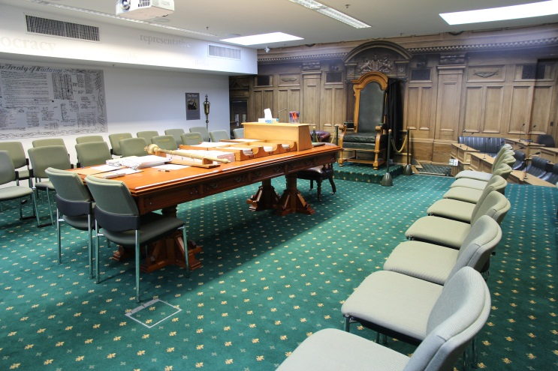

We lovethe debating chamber ‘wall’

**Professional Development, Networking, Working with other Agencies**

We have continued throughout the year to find opportunities to enhance the work we do by networking with other agencies engaged in work that is connected to our service.

I attend Growing Active Citizens meetings about four times a year which is a group made of members from Local Government New Zealand, the Electoral Commission, Ministry of Youth Development, Registrar of Electors and other various agencies all concerned with promoting participation and engagement in the democratic process. These meetings allow us to keep each other up to date with the activities we are all involved in and provide support and feedback on the work we do.

I have also formed relationships with the National Library, Archives New Zealand and the educators working within the courts and Government House. We have been looking at a number of ways we can work together to provide coordinated experiences for school groups. Some possibilities include studies around the Treaty of Waitangi and women’s suffrage. From next year these documents will be housed in a new space created by Archives which is just over the road from the NZ Parliament. Physical proximity to us means the ease by which groups can visit us both lends itself to collaboration.

Opportunities for professional development for teachers are also being organised for the new school year. A PD day in the first week of the term 1 school holidays in 2014 will involve teachers spending a day visiting Government House, the Supreme Court and Parliament. Another will involve the Electoral Commission and Parliament and will run as a lead up to our general election. With the completion of our new resources we are mindful that professional development for teachers will ensure the resources are used with confidence.

**Youth Parliament**

Education Services was involved in the very successful Youth Parliament that ran this year. The NZ Parliament runs this event every 3 years and it is largely run and funded from the Ministry of Youth Development in conjunction with the Clerk of the House. This year however we were brought on board to give support by providing training and information for the MYD staff to ensure the youth MP’s had more background and understanding of the work of Parliament before they participated in the event. We hosted and presented as part of a training day for the youth MP’s. This day was videoed and sent to other youth MP’s around the country. We really enjoyed taking part and indications are that we will continue to be involved in this way in future.

**So what’s next?**

Next year is election year in New Zealand so we are expecting a busy year for Education Services. We will be launching our teaching resources to the education community, providing professional development for teachers and developing our visit options including an election themed visit. Work will continue to develop website material for students and teachers to use and we will explore some options for events involving in particular senior students. I think that will be enough to keep us busy for now………

No reira, tēnā koutou katoa