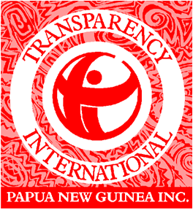 **Open Parliament Project**

Established in 1997 as a national chapter, Transparency International Papua New Guinea (TIPNG) is part of the global civil society organization leading the fight against corruption. There are over 100 chapters worldwide and an international secretariat in Berlin. We raise awareness on the damaging effects of corruption to empower people to make an active choice against corruption. We work with our partners in government, business and civil society to develop and strategize ways to tackle corruption. TIPNG has a current membership of 31 corporate organizations from the public and private sectors, 288 individual members, 4 associations and 2 families.

The 2011 CPI and UNHDI ranked PNG 154/182 and 154/189 respectively. These poor rankings are a real reminder of the detrimental impact of corruption on development in the country.

***Our Vision, Mission, and Strategic Goals***

***Vision***

A country where government, politics, business and individual citizens live and operate within the rule of law, are subject to good governance and are free from corruption

***Mission***

To inform, educate and empower all Papua New Guineans, regardless of whom they are and where they are from to make an active choice.

***Strategic Goals***

1. ***PEOPLE –*** To build enduring relationships and empower people in PNG to take action against corruption
2. ***LAW –*** To secure the development and more effective enforcement of laws and standards in PNG and reduce immunity for corrupt acts.
3. ***INSTITUTIONS –*** To contribute to the effective implementation of anti-corruption programs in leading institutions, business and resource sector.
4. ***VALUES –*** To contribute to instilling a higher level of integrity in our society as stated in our constitutions.

**OPEN PARLIAMENT PROJECT**

One of the many projects and programs of TIPNG to contribute to achieving our strategic goals and vision is the OPEN PARLIAMENT PROJECT (OPP). The OPP falls within the strategic goals of People Engagement, Institutional Strengthening and Instilling Values of integrity in people and institution.

The OPP is an initiative of TIPNG, funded for two years by the European Union to work in partnership with the Speaker of the National Parliament of Papua New Guinea to support his vision to “restore, reform and modernize” the National Parliament institution.

Access to Parliament information is crucial for the empowerment of the people, generates interest among our citizenry, promotes good governance; enhance best legislative practices and citizens engagement in parliamentary democracy.

Therefore TIPNG and the Office of the Speaker have entered into a partnership agreement to provide access to parliament information through the “Open Parliament“ initiative and to conduct civic education on the work of parliament.

**Goal of OPP**

To build the integrity of the national parliament of Papua New Guinea and enhance the role of parliament as law maker, accountability agent and peoples representative through information dissemination and citizens engagement in the parliamentary democratic process. Thus improving the responsiveness of the national parliament to societal development needs.

**Objectives**

* Encourage and help MPs to share information with the public about themselves and the work good work they do.
* Enable the public to have a better understanding of the roles and responsibilities of their elected representatives—the MPs.
* Provide a platform for the public to communicate with their elected representatives and vice versa.
* Increases the public’s awareness of the functions of the parliament, its committees and its proceedings.

**Main Activities**

In support of the Speakers vision, establish a database and website of information on the work of Parliament and the Members. The database will then be linked SMS as one of the many mediums for public access. This project as we believe is one of a kind. The OPP is not designed to criticize Individuals Members of Parliament or the institution of the Parliament itself.

**What sort of information will be made available through the website and SMS?**

* MP’s Profile
* 2012 National Election Results
* MPs Attendance during sessions
* Inaugural Addresses
* Personal statements from MPs
* Office Contact Information
* District Support Grants Reports
* Number of electoral visits
* Days parliament sits
* MP voting records on bills
* Progress of Bills
* Bill passed
* Committees reports

Other avenues of dissemination of information besides website and SMS include:

### Printed reports

### Email: [openparliament@parliament.gov.pg](mailto:openparliament@parliament.gov.pg)

### Newspaper Articles/ Inserts

### Radio Interviews

### Website: [www.parliament.gov.pg](http://www.parliament.gov.pg)

### Targets

### The target of OPP is:

### All citizens

### Voters

### Members of Parliament

### Expected Results

### Assuming the activities can be sustained over at least two electoral cycles we expect measurable improvements in regards to:

### More informed and demanding voters

### More efficient and accountable parliament an public service.

### Reduced corruption

### Higher quality candidates

### And as a consequence citizens will have more access to core services and their rights as guaranteed under the constitution.

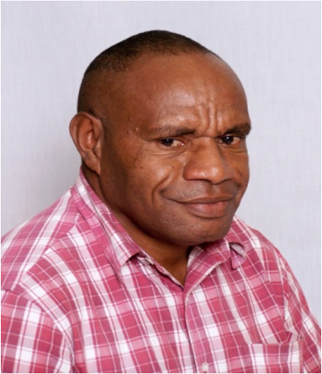**John B Varey**

Project Manager

Open Parliament Project

Transparency International (PNG)

2nd Floor, IPA Haus, Konedobu

P.O.Box 591, Port Moresby. NCD.

Papua New Guinea

Tel: +675 3202188

Mob: +675 73247189

Fax: +675 3202189

Email: [pm.opp.tipng@gmail.com](mailto:pm.opp.tipng@gmail.com)

Web: [www.transparencypng.org.pg](http://www.transparencypng.org.pg/)