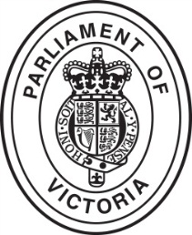

***Tours and Customer Service Unit***

The Tours and Customer Service Unit (TCSU) is a part of the Serjeant-at-Arms’ Office in the Legislative Assembly. The TCSU offers a broad range of community engagement and educational experiences for members of the public and school students from primary, secondary, tertiary and adult education institutions. Tours and presentations are conducted and facilitated by Legislative Assembly Tour Guides.

All of the TCSU’s school presentations are designed to provide students with information relevant to Victorian Essential Learning Standards (VELS) curriculum, covering such topics as representation and the democratic process in Victoria, the three levels of government, how a law is made, and the history of Parliament and Parliament House.

**Booked tours**

Booked tours are available to any group of six or more people. Primary and secondary schools, tertiary institutions, ESL classes, community groups and business organisations are among the many people that come for a booked tour of Parliament House.

As many as eleven booked tours can be conducted on non-sitting Mondays and Fridays, ten tours on non-sitting Tuesdays and Thursdays and, seven on non-sitting Wednesdays, when much of the schedule is taken up with role plays. During sitting weeks nine tours can be conducted on Tuesdays and Wednesdays, and seven on Thursdays.

By far the majority of booked tours are made up of primary schools, secondary schools and tertiary institutions, with 1020 bookings made during 2012–13 totalling 23,900 children and 4,100 adults.

**Parliament role plays**

Parliament role plays (PRPs) are one of the most popular community engagement programs on offer. Demand for the program is high, and role plays are often fully booked for the year within a few months of bookings becoming available. In 2012/13 36 PRPs were conducted.

Role play sessions are held each non-sitting week on Wednesdays at 9.30 am and 11.00 am, and the program is open to students in years 5, 6 and 7.

Each role play includes a PowerPoint presentation which provides an introduction to key information and concepts, and video extracts, assisting students to better understand the Parliament’s role as a lawmaker and the processes involved in debating bills.

The PRP provides a chance for students to act out different roles in Parliament and pass their own law. Students use the Legislative Assembly Chamber, dress up and use props. They act in the roles of Speaker, Clerk, Serjeant-at-Arms, Premier, Leader of the Opposition and front benchers. Students choose an issue to debate, read from prepared scripts and vote on a proposed law.

**Metropolitan school visits**

Metropolitan school visits are held on Tuesdays and Thursdays of non-sitting weeks, and presented by senior tour guides. On each of these days, staff travel from Parliament House to schools located within the metropolitan area to deliver a PRP to students in years 5, 6 and 7.

During the 2012–13 financial year, 30 Metropolitan School Visits were conducted at schools in the Melbourne metropolitan area.

**VCE legal studies role play**

The role play for year 11 and 12 is designed to be as relevant as possible to the VCE legal studies curriculum.

Students get a choice of debating either the *Summary Offences Amendment (Upskirting) Act 2007 or the Crimes and Domestic Animals Acts Amendment (Offences and Penalties) Bill 2011*. The scripts include Hansard extracts from members’ actual contributions during the second reading debate. A PowerPoint presentation complements the role play. During the 2012/13 financial year 24 VCE Role Plays were conducted.

**Regional presentations**

During 2012–13 the outreach program team conducted five regional visits to towns throughout Victoria. The aim of the regional program is to take the community engagement and education programs to regional Victoria so that students who would normally miss our education programs because of distance are given the chance to participate. Parliament tour guides travelled to regional towns for 2-4 days and conduct PRPs for local school students in years 5, 6 and 7. In preparing for regional visits, staff undertook reconnaissance visits to investigate facilities and distribute information to local schools, which was followed up with formal invitations once dates and venues had been locked in.

In this 12‑month period our team conducted presentations in Portland, Ararat, Wangaratta, Phillip Island and Traralgon. In total, 25 schools and almost 1,000 students participated.

Members of Parliament from both the Legislative Assembly and the Legislative Council attended many of our sessions, where they actively engaged with the students and explained their role within Parliament.

**Public Tours**

Public Tours are open to all members of the public who wish to visit Parliament House to discover its rich history and learn more about how Parliament functions.

Tours run from 45 to 60 minutes and are conducted by Legislative Assembly Tour Guides. Legislative Council Attendants conduct the 9:30am tour.

As one would expect, our visitors come from all over Victoria and Australia. In 2012/13 approximately 14,500 visitors attended public tours.

**Architecture Tour**

In November 2012 the TCSU launched its newest tour, the Parliament House Architecture Tour. The tour is designed for students studying architecture and design or for members of the public with an interest in architecture and historically significant buildings.

Visitors are given a PowerPoint presentation focusing on some of the key aspects of the building before being taken on a tour of the building that includes areas not normally accessible to members of the public.

The Architecture Tour is conducted on the last Friday of each month at 2pm and lasts for 90 minutes. If demand is great we will look at expanding the number of tours we conduct in 2013/14.

**Open Day**

Each year the Parliament of Victoria opens its doors for our annual Open Day. In 2013 about 2,500 visitors came through the doors, with many families and Melbourne residents who are unable to visit the building during the working/school week making the effort to visit.

Business units from across the Parliament had displays, as did our colleagues from Victoria Auditor General’s Office, the Victorian Electoral Commission and Public Records Office Victoria. Staff were on hand to talk to visitors about our work and our organisation. The Speaker and the President also attended and chatted to members of the public about their roles.

**Open House**

Open House Melbourne is a not-for-profit association that aims to give the public an opportunity to explore buildings of architectural, engineering and historical interest around Melbourne’s CBD. It focuses on an annual weekend of ‘open buildings’, and began in 2008 with eight buildings open to the public. Parliament of Victoria joined the program in 2011, when 75 buildings were open.

Tour Guides from the Legislative Assembly and the Legislative Council take tour groups through the Vestibule, Assembly Chamber, Council Chamber, Library, Queen’s Hall and the Knight-Kerr Room. Tours start every fifteen minutes. In 2013 we had over 1100 visitors.

**Youth Parliament**

Every July over three days the Parliament hosts the annual YMCA Youth Parliament. Twenty teams participated in 2013 with almost 120 Youth parliamentarians filling the Chambers throughout the event.

Participants, aged between 16 and 25 stage a mock sitting of Parliament where they introduce, debate and pass (and sometimes defeat) bills that they had written themselves.

The process is designed to reflect as closely as possible a real sitting day in each Chamber, so that participants can get a deeper understanding of how Parliament functions and how bills are passed into law. It also provides participants with an opportunity to raise issues of concern to them and debate them with their peers.

Some of the topics debated this year included legalising the use of cannabis for medical purposes, increased public transport services in rural areas, increased mental health education in secondary schools, and regulating dairy prices. The bills that were passed were handed to the Treasurer, the Hon. Kim Wells, at the closing ceremony, where he pledged to share the bills with his Government colleagues.

**Work Experience**

The Parliament offers a work experience program for secondary students wishing to obtain knowledge and skills associated with parliamentary practice and procedure. The program, which is administered by the Clerk of the Parliaments, offers participants the opportunity to undertake a week’s work experience across a range of parliamentary work units.

In 2012–2013 four students spent time with their local Member of Parliament, attended Question Time in both Houses and met with Chamber officers and staff. The students were particularly appreciative of the structured work experience program and the amount of time devoted by parliamentary staff to assist them during their week at Parliament.

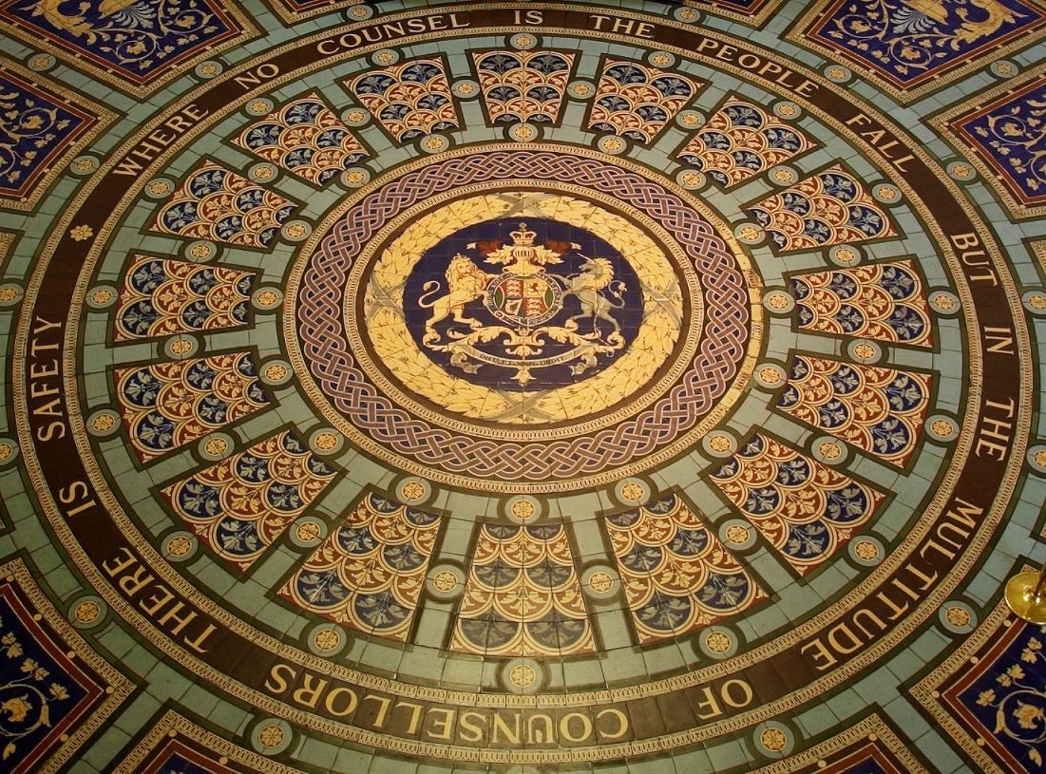

***Education and Community Engagement Unit***

The Unit provides more specialised programs such as tours and presentations for tertiary and adult education sectors and PD for teachers. It produces print and audio-visual resources and provides educational resources and advice to MPs.

The Unit reports to the Director, Information Services, in the Department of Parliamentary Services. It currently comprises a Community Engagement Projects Officer and two part time contractors who work the equivalent of one and a half to two days per week.

One of the contactors, Leanne Newson, is also currently the Education Officer at the Law Institute of Victoria. Her role with Parliament includes developing joint programs in Legal Studies, presentations and resources for history teachers and scoping various new programs the unit might provide.

The other contractor, Daryl Evans, is an adult literacy and numeracy specialist. He is currently working on a number of projects including an outreach program and a series of units for VCAL teachers and students, which will soon be on the Parliament’s website.

Leanne Newson has provided training, for the Legislative Assembly Attendants who provide school and outreach programs, in the Department of Education and Early Childhood Development curriculum requirements so that they can customise their presentations. These presentations were previously tailored to the Victorian Essential Learning Standards (VELS) at levels 4 (Years 5/6) to 6 (Year 10) and will be reviewed to enhance the requirements of the Australian Civics and Citizenship Curriculum when finalised and implemented. The Unit was involved in the consultation process and review of the Draft Civics and Citizenship Shaping Paper and will continue to provide expert advice to the Australian Curriculum and Reporting Authority (ACARA). The presentations are also focused on the requirements of the Victorian Certificate of Education (VCE) for years 11 and 12.

The Unit also provides:

* Professional Development for school teachers, at Parliament House, as part of the *Civics and Citizenship Network*.
* Specific presentations for VCE Legal Studies students as part of the Victoria Law Foundation’s *Law Talks* program in regional Victoria. These include a role play for year 11 students and for year 12 a pre-exam presentation around Unit 3 of the study guide covering the legislative process.
* The Unit works with the Department of Education and early Childhood Development in the provision of the Constitutional Convention programs in regional Victoria and the State Convention at Parliament House which sends delegates to the annual National Convention in Canberra. Teacher professional development versions of the model UN Conventions also take place in Parliament House. The Unit also works with DEECD to run the State Junior School Council Congress.
* Customised courses for tertiary students have continued this year, and are now taken by the Legislative Assembly attendants.
* We have provided some PD sessions, including a tour of Parliament, for B.Ed. and Dip.Ed. students in civics and citizenship, legal studies and history teaching methods.

**Parliament of Victoria Website**

The website has a dedicated education section which shows our resources and programs and has resulted in regular requests for these.

There are two interactive units on the website. *How a Law is Made* covers the complete legislative process, from the inception of a need for a bill through Cabinet and both houses, to Royal Assent. The *History Timeline* covers Victorian history, with an emphasis on government and voting, from separation from NSW to the present day. These were created from the library of film created in the production the DVDs *Making the Law* and *From Westminster* *to Spring St.* Both of these DVDs have been remade to reflect the 57th (current) Parliament, and the *How a Law is Made* interactive unit has also been changed to reflect this. Around half of the approximately 80 YouTube clips which were put on the website using footage from the filming of these DVDs were replaced this year to reflect the current Parliament. This project involved interviewing the current Presiding Officers, and was undertaken in conjunction with the Parliament’s Broadcasting Unit which did all the filming and editing. The clips cover significant historical information and interviews with key participants in, and commentators on, the parliamentary process.

The Legislative Assembly has developed two animated videos which are on the website, one called *How Parliament Makes Laws*, and the other called *Parliament of Victoria Explains: How Parliament’s Committees Work*. A third one on state elections is in the pipeline. With eye-catching graphics, they are easy to understand and explain the processes clearly.

Some compact classroom modules for adult education teachers will also be added to the relevant section of the website within the next few months.

**Social Media Strategy**

A goal in the Parliament of Victoria’s 2010–14 Strategic Plan is to increase public awareness of, and opportunities for engagement with, the functioning of Parliament. Developing a social media strategy for the parliamentary departments was identified as an important step. As a result of this, the Parliament now has two Twitter accounts, one for the Parliament and one for Committees. The animated modules on the website mentioned above are also part of this strategy, and eventually a Facebook page will be created.

**Print and Audio Visual Resources**

All our current print and audio-visual resourcesare listed on the website.

Last year we released new versions of two of our DVDs, *Making the Law* and *From Westminster to Spring St*. These were remade to reflect the new Parliament that was elected at the end of 2010. The three *Inside Parliament* DVDs (primary, secondary and adult education) have not yet been replaced, and work will commence on replacing them following the next election in 2014.