Making an ePub

Queensland Parliament’s experience

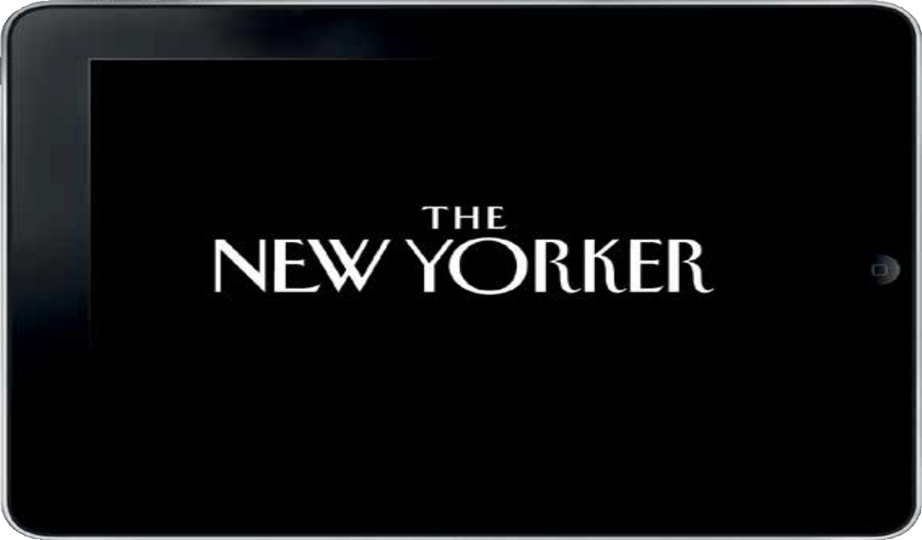





## Contents

Summary 1

Why Make an e-Book? 2

Why an iBook? 4

Our Process 6

Viewing drafts 6

Technical Steps 6

iBooks Author 7

ISBN 8

Publishing 8

HelpDesk 10

Post-Publishing Updates 10

Using an Agency 11

Feedback 11

Postscript 12

* The Queensland Parliemt iBook was a joint project with Queens- land University of Technology
* Book made using Apple’s iBooks Author (downloaded from Itunes)
* Required an Apple computer – one of the latest models
* Required an iTunes account
* Purchase of an ISBN required
* Allow plenty of time and then double it





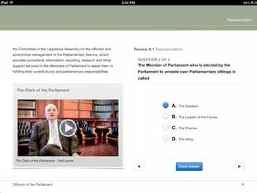

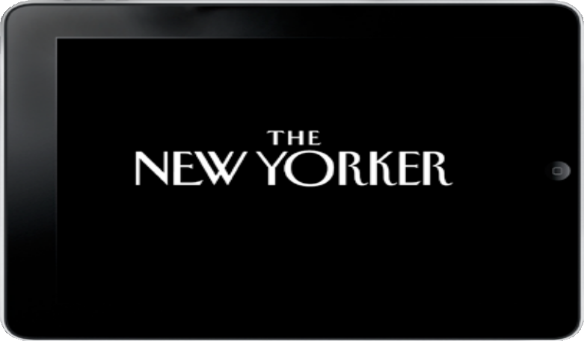



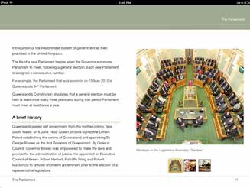

Statistics show increase in usage of ePubs and portable devices (see info graphics on following page).

Allows:

* interactivity
* revision questions at end of chapter
* searchable content
* study notes

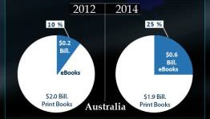

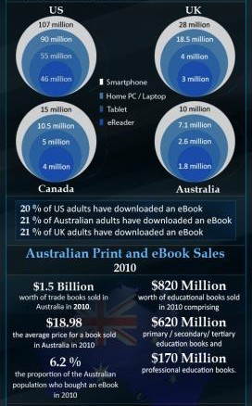

(source <http://www.ebookhands.com/ebook-consultation/>

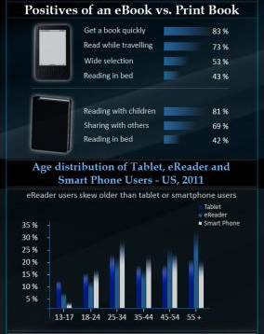

viewed on 3/9/13)

## Why an iBook?



* Electronic publications are called e-books (ePub is an open e-book standard that works with just about any e-reader).
* There are about 17 different formats for all e-books which includes Kindle and Android devices.
* Each format has different technical specs and require different output formats to export to. Each format requires manual eformatting and validation. This means you will need to create multiple versions of your eBooks if you want to make it available everywhere.
  + Some of the biggest e-books are formatted for: Apple iPad and iPhone, Amazon Kindle™, SONY® eBook Reader, Barnes & Noble NOOK, Android tablets and smart- phones.

List of EPUB softward and platforms

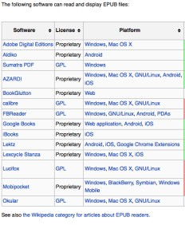

Most dedicated e-book readers support the ePub format, although the Amazon Kindle line of devices is a notable exception. EPub reading software is also available for all modern smartphones.

Devices that support ePub include:

* Android devices (using Aldiko, CoolReader, FBReader, and so on)
* Barnes & Noble Nook
* BlackBerry PlayBook
* BeBook
* Bookeen Cybook Gen3, Cybook Opus
* Boox
* COOL-ER
* Cruz (Velocity Micro)
* eClicto
* ECTACO jetBook and ECTACO jetBook Lite
* eSlick
* GNU/Linux tablets and PDAs such as Sharp Zaurus and Nokia 770, n800, n810, and n900
* Hanlin eReader
* iPad, iPhone, and iPod Touch (Lexcycle Stanza or iBooks on iOS 3.2+)
* iRex Digital Reader 800 and 1000
* iriver Story
* Kobo eReader
* Plastic Logic
* PocketBook Reader
* Sony Reader
* Windows Phone (using Freda or Stanzetta or other similar apps)

(source [www.wikipedia.com](http://www.wikipedia.com/) viewed on 3/9/13 [http://en.wikipedia.](http://en.wikipedia/) org/wiki/EPUB)

Comparision of e-book formats <http://en.wikipedia.org/wiki/> Comparison_of_e-book_formats

Apple have their own proprietary ePub called iBook. Apple iBooks are currently the only ones with interactive function- ality (see the Queensland Parliament iBook.)

IBooks takes e-books to the next level. The software for this is called IBooks Au- thor and it is easy to use and comes with templates that you can start from.

In our case, the publication had been creat- ed in iBooks Author when our team joined the QUT project.

It was hoped this publication could be re- leased to cover other ePub devices; how- ever this would mean creating from scratch the same publication in either Pages (apple software $20.99) or InDesign (Adobe Crea- tive Suite) so as to have an e-pub version. The e-pub version would be available to some other formats and would have none of the interactivity that the iBook has.

It was decided in order to cut down extra work and to minimize risk regarding version control over several publication formats to stay with IBook only, initially.

Some of these ePub providers are starting to support some ebook versions (e.g. epub and mobi). So over time, if this trend con- tinues. this could make publishing to e-pubs easier.on

*If you create your content in iBooks Author and publish with Apple, Apple do not have have the copyright to that publication, however if a fee is charged for the work and it is in the .ibooks for- mat, the work may only be sold through the iBooks Store. If the work is in a dif- ferent format, such as PDF or ePub, this restriction does not apply.*

*When the work is provided for free, it can be distributed through the iBooks Store or by other means, including when the work is in the .ibooks format.*

## our ProCess

QUT developed the publication with a team of specialists (graphic designer, IT manager, team of audio and video students) lead by senior academics.

Our involvement in the project was to provide the text for the book (already existing), source and provide images for the publication and to very carefully proof read the entire publica- tion.

## VieWing drafts

We did not have an iPad, which made viewing the end product impossible. Initially PDF’s were printed out or emailed to us for this purpose. As the project neared completion QUT lent us an iPad occasionally so we could view and make edit notes for their graphic designer.

Have the portable device that you are making the publication for. (It is essential to be able to see your end product, especially for testing, viewing an editing.)

## teChniCal stePs

Our IT section had 1 apple laptop. Luckily it was relatively new, so were able to update the Operating System, then we were able to purchase the latest Operating System (Mountain Lion) and then put on the iBooks Author, which required the latest operating system to run on. Having iBooks Author allowed us to open and view on the laptop draft versions of the book that were sent to us by QUT. Viewing these in Ibooks Author still didn’t allow us to see the end product, but it was much easier than reading the PDF version.

Technically we all had quite a steep learning curve. Neither QUT nor our staff were epub publishers or had any experience in this area. IBooks Author had been only launched and released by Apple earlier in the year (2012). Not only were we lacking in epub knowledge but also our technical infrastructure was not able to meet our requirements. It often was a case of 1 step forward, 2 steps back. Sample of steps we took:

* Update laptop to the latest version of Snow Leopard
* Purchase and upgrade Mac operating system to Mountain Lion (purchasing of software…..)
* Create Apple Account
* Create iTunes Account
* Create iConnect account
* Link the credit card to ITunes
* Download IBooks Author software from App Store
* Upload/Submit IBook to ITunes (through iConnect account)

*It was also a new challenge working with an external body. Their processes and quality con- trol were different to ours.

The apple laptop was not connected to the network, so getting files to and from it was time consuming.

Updating the operating system and installing iBooks Author required internet access. The building had recently been set up with Wi-Fi but the desk we used was a in a Wi-Fi black spot. The IT firewall prevented software from downloading when plugged in to the network from their office. Luckily IT’s testing environment offered internet access outside of their firewall and though it was very slow, we were able to update the laptop as required.

As Apple’s business model is to continually release updates to their, this sometimes prevent- ed us from opening our iBook working files. We had to take the laptop to IT and leave it to connect overnight to update to the latest OS or IBooks Author.

Some of these steps above appear to be simple and easy, such as linking the credit card to our newly created iTunes account. Surprisingly however, this was problematic and took a lot more time to complete. This proved to the norm for most processes in this project.

## iBooks author

IBooks Author was used to create the iBook. IBooks Author is Apple’s own proprietary soft- ware.

IBooks Author is available from the Apps Store and is free. To be able to use this you must have the current operating system on your Apple computer. You need to have iBooks Author v2 (as at Sep 2013) now to produce an iBook that will be accepted by Apple.

IBooks Author offers two types of formats – landscape with portrait or portrait only. If you use the landscape with portrait, which our publication does, when the tablet is rotated from landscape to portrait the layout changes significantly. Not only does is lose its visual impact, but the reader could miss out on the interactive elements. In hindsight, I would recommend portrait only for our publication.

iBooks Author comes with, as standard, study notes, dictionary, and glossary.

Apple also offer Pages ‘09 ($20.99), iBooks Author (free), Pages ‘09 is a word processor and document layout tool, that allows you to open and work with Microsoft Office documents

as well as convert your files to RTF , plain text, ePub or PDF files.

ITunes Producer (free), ITunes Producer 2 (as at 11/9/13) is also required in order to upload your book.

## isBn

We obtained an ISBN from Thorpe-Bowker.

The cost of this was $42 and must be paid for by credit card.

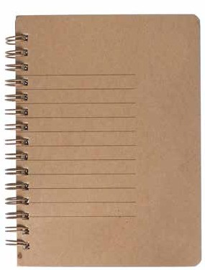

Thorpe-Bowker

Ph: 03 8517 8349

[isbn@thorpe.com.au](mailto:isbn@thorpe.com.au)

[www.thorpe.com.au/en-AU/](http://www.thorpe.com.au/en-AU/) products/servident-isbn.shtml

## PuBlishing

In order to publish to the iTunes store we needed to open an Apple account (which requires a credit card number) and an iConnect account.

Connect account address: Itunesconnect.apple.com

Submitting the book required screen captures from the publication to be uploaded, as well as entering various metadata and providing cover artwork for thumbnails in iBooks.

ltunes Connect screen shot

•iTunes Connect



Parliament and Government InQueensland

•

Metadata Im

Parliament and Government In Queensland

level 3, Queensland Parliament



J.W;t 10 UIH.471.18

ISSN '97111lfi.46Sll"i8ll

Vtnlon t.2

)Ult.v\ •On )l )t«u



"""





S...bt!Uc Liavtl l.Qutt11sla11d '*"''"".it

kl l\'\I q.-n..tand ,&111a......

Auctior Son Hir!tc hrQ<11M111,. Qiittnsl•1141

t)o'4t"91ll>ft L......1 "''"11r llw, ,.,.,•.,..,., .....ciq....,.1 ..0 lnf-•I...., book' ptOYld• ...111-cHpi.h .........i.w ....r.rua......i•...i

Co\'tr t 11101111,Ml;aflll,

**Jqil** lftltlldl

Qvfft1•la11dP.\Al•-ltl



1'1..,l lC"91ll 1IS P*llO

C.i.WG'Y sq,.-. **U:V.<;**

C-.l('QOIV (..G..M..,l.lo".A'./



Wh.n's N w InThis venlon



Assets

PubllcatiOl'I

Vtn•Ol'I u

0,,lot Jll4l4.2<1U

V1tW O.Wb

Prcvi1-w

-

CrWtdu, t»blUhufro U

.ro.w Jul'J4,.:IOU

w0tfM1

CO\-tr*Al''*

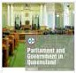





."'





After this step, ITunes connect validates your files. If they are technically OK, then files can be uploaded.

The whole publication process was done at QUT using their integrated Wi-Fi, mac environ- ment. It took about an hour or so for the files to upload.

It is possible that Apple, during their review process, will find errors or things they want you to amend. If so, you will see notifications in your ITunes Connect account.

Once the files are with Apple, there is no indication from Apple how long it will take them to approve your publication. In our case it took over 4 weeks without any errors or correc- tions being asked for (but have heard of some cases taking several days and others taking six weeks).

We created a PDF version of the iBook which is available on our website and available for all to read and download. Of course the PDF misses out on the interactivity – such as quizzes.

## helPdesk

Our work environment is PC (not Mac). Our IT section is not familiar with the Apple environ- ment.

We wrote the documentation for our IT helpdesk in case any MP’s called our IT section re- quiring assistance to download the iBook or install iBooks etc.

## Post-PuBlishing uPdates

Two updates have been made to our publication since it was launched. The first was done by QUT, the second by us. Both have been minor text edits.

We manage the publication through iTunes connect. You login and submit the new files through this, without having to go through providing screen shots and entering the metadata again.

## using an agenCy

If you want to make the job easier for yourself, you can go to any one of a number of agen- cies who deal in turning publications into e-book and publishing them for you.

An agency will provide their services for a fee.

For example, a web search found: ebookshands.com who offer epub conversions, formatting of a book to a digital format (ePub, .Mobi, ePDF, Kindle, ePub 3, HTML5), provide multi lan- guage conversion, specialize in education/academic publishing and (digital) magazine publish- ing.

## feedBaCk

The following feedback has been received on the Customer Reviews section of the Itunes site (and we don’t even know these people)!

Cool

by Douglas Ottoman Greg

A really nice bit of work with great video of parliamentary officers and opening of Parliament. The flow chart of legislation processes is very easy to understand. The quizz at the end of each section is great for revision. Great graphic design values. Tip: view in landscape mode.

Nice execution by Elnicho

This is the kind of material the iPad was made for. Nice use of content.

## PostsCriPt

We now have an Apple computer and an iPad.

The iPad is used to demonstrate the iBook in person or to a group, present PPTs and videos. Two connector cables need to be purchased then they are simply connected to a projector

or TV using an iPad HDMI connector ($45 Digital AV Adaptor) and a HDMI cable ($50).

# 1

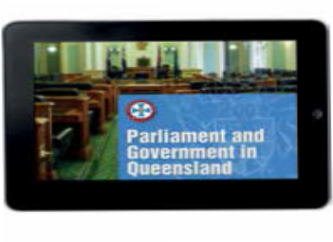

Apple iPad HDMI connector



**2**

connects iPad to HDMI cable

HDMI cable

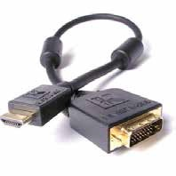

**3**

connects Apple connector cable to

projector or TV